PROJECT ON RIDE SERVICE REVIEWS

Data Overview:
1. The Business Context
This dataset serves as the "Single Source of Truth" for evaluating the daily reliability of ride-hailing operations throughout July 2024. The primary business objective of this data is to help management identify exactly where operational bottlenecks are happening and why revenue is leaking.
2. The Grain
The dataset contains exactly 103,024 transactional records. The "grain" (or lowest level of detail) is the individual booking level—meaning every single row represents one unique attempt by a customer to book a ride.
3. The Business Metrics
To accurately diagnose performance, the data captures 19 distinct attributes divided into three strategic business areas:
- Operational Metrics: Includes the exact wait times for both vehicles and customers (V_TAT / C_TAT), geographic pickup/drop-off hubs, and the final booking status (Success vs. Cancelled).
- Financial Data: Tracks the total potential booking value of each ride and the payment method used (Cash, UPI, Credit Card), allowing us to tie operational failures directly to lost revenue.
- Quality & Supply Constraints: Captures specific textual reasons for incomplete rides (e.g., "Driver not moving" or "Car related issues") and post-ride ratings, helping us evaluate fleet health and driver behaviour.

Data Cleaning:
First, we figured the business problem which was ‘revenue leakage’ due to incomplete bookings. So, we focused on cleaning the data on the following steps based on ‘Booking Status’ column:
- Scenario A (The Ride was a Success): Canceled by Driver = "NA - Completed Ride"
  - Canceled by Customer = "NA - Completed Ride"
  - Incomplete Rides = "No"
- Scenario B (The Driver Canceled):
  - Canceled by Driver = [The actual reason, e.g., "Car related issue"]
  - Canceled by Customer = "NA" (Because the customer didn't do it)
- Scenario C (The Customer Canceled):
  - Canceled by Customer = [The actual reason, e.g., "Driver not moving"]
  - Canceled by Driver = "NA" (Because the driver didn't do it)
- Scenario D (The Ride Failed, but no reason was written down):
  - Incomplete Rides Reason = "Unknown" (Avoided guessing)

Data Segmentation with STAR Schema:
We do not join the tables based on the Fact table's Primary Key (`Booking_ID`). Instead, we join the central Fact table to the Dimension tables using Foreign Keys that map directly to the specific Primary Keys of each individual Dimension table to the centralized Fact Table.
The exact architectural breakdown of the Primary Keys (PK) and Foreign Keys (FK) used to build the Star Schema:

The Fact Table (`Fact_Bookings`): The Primary Key is `Booking_ID`. This establishes the "grain" of the table (one row = one unique ride) and holds the other quantitative attributes.
The Joins: To connect this Fact table to the surrounding dimensions, the following four key mappings were used.
1. The Central Fact Table Contents (Fact_Bookings)
Acting as the numerical engine of the dashboard, the central fact table strips away heavy text descriptions and stores only the critical quantitative KPIs and the connective keys.
- The Primary Grain: Booking_ID (Ensures every row represents exactly one unique ride attempt).
- The Connectors (Foreign Keys): Customer_ID, Vehicle_Type, Date, and the engineered Status_ID.
- The Core Business KPIs (Measures): Booking_Value and Payment_Method: To track financial volume and transactional risk.
  - V_TAT and C_TAT: Vehicle and Customer wait times to pinpoint operational friction.
  - Ride_Distance: To track fleet utilization and wear-and-tear.
  - Driver_Ratings and Customer_Rating: For quantitative quality assurance.
- Geographical Data: Pickup_Location and Drop_Location are retained to allow for regional filtering of the KPIs.

2. The Customer Join (Entity)
- Dimension PK: `Customer_ID` (inside `Dim_Customer`)
- Fact FK: `Customer_ID` (inside `Fact_Bookings`)
- The SQL Join: `ON Fact_Bookings.Customer_ID = Dim_Customer.Customer_ID`

3. The Vehicle Join (Entity)
- Dimension PK: `Vehicle_Type` (inside `Dim_Vehicle`)
- Fact FK: `Vehicle_Type` (inside `Fact_Bookings`)
- The SQL Join: `ON Fact_Bookings.Vehicle_Type = Dim_Vehicle.Vehicle_Type`

4. The Time-based Joins (Entity)
- Dimension PK: `Date` (inside `Dim_Date`)
- Fact FK: `Date` (inside `Fact_Bookings`)
- The SQL Join: `ON Fact_Bookings.Date = Dim_Date.Date`

. The "Junk Dimension" Join (Review entity)
As we cannot use heavy text strings (like cancellation reasons) as an efficient primary key, a new one was engineered (surrogate key):
- Dimension PK: `Status_ID` (A newly created integer Surrogate Key inside `Dim_Ride_Status`)
- Fact FK: `Status_ID` (Inside `Fact_Bookings`)
- The SQL Join: `ON Fact_Bookings.Status_ID = Dim_Ride_Status.Status_ID`

DASHBOARD ANALYSIS:
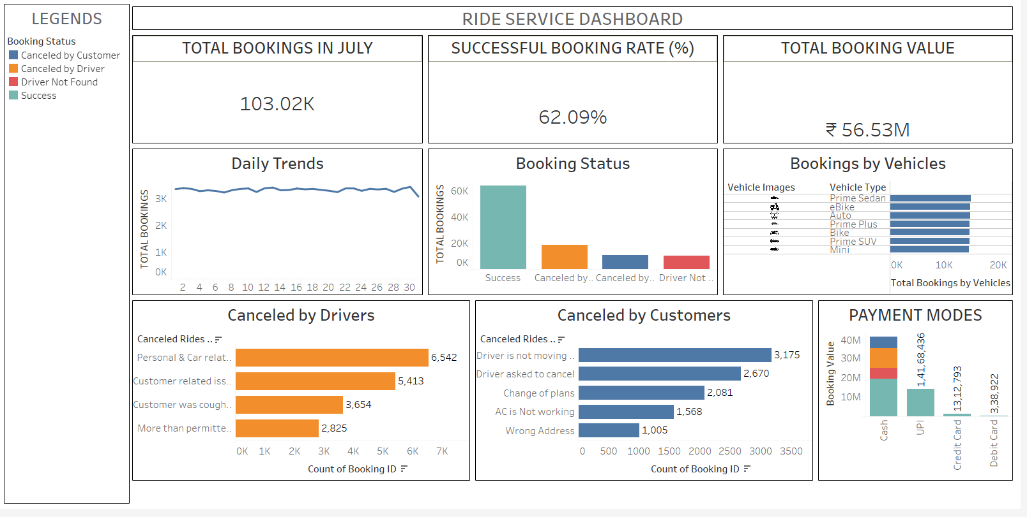
Executive Summary: July Operations Performance
In July, the platform captured 103,024 ride requests representing a total potential booking value of ₹56.5 Million. However, the platform is currently operating at a 62.09% Success Rate. This indicates a severe leak where roughly 38% of top-of-funnel demand is failing to convert into completed trips, leaving massive revenue on the table.

Phase 1: Problem Framing (Demand vs. Supply)
The first analytical step is to determine if the 38% failure rate is caused by a lack of customer demand or a failure in operational supply.
- Consistent Market Demand: The "Daily Trends" line remains remarkably flat at roughly 3,000 to 3,500 rides per day. There are no erratic market spikes or weekend-only surges.
- Balanced Fleet Utilization: The "Bookings by Vehicles" distribution is perfectly even across all asset classes (Prime Sedan, eBike, Auto, etc.).
- The Bottleneck: The "Booking Status" distribution clearly shows that Driver Cancellations and Driver Not Found errors drastically outnumber Customer Cancellations.
The Insight: The marketing team is successfully delivering consistent, daily customer demand across all vehicle types. The revenue leakage is 100% a supply-side fulfilment issue.

Phase 2: Root Cause Analysis (The "So What?")
By drilling down into the specific failure statuses, three clear operational crises emerge on the ground:
1. Platform Manipulation (Manipulating the System)
Even when the customer initiates a cancellation, the data proves it is driver-instigated. The top customer cancellation reasons are "Driver is not moving" (3,175 cases) and "Driver asked to cancel" (2,670 cases).
- The "So What?": Drivers are accepting rides they do not want, but refusing to drive to the pickup location. They do this to force the customer to press cancel, allowing the driver to avoid the platform's cancellation penalty. This creates a highly toxic customer experience.
2. Asset & Shift Degradation
When drivers explicitly cancel rides, the overwhelming primary cause is "Personal & Car related issues" (6,542 cases).
- The "So What?": The physical fleet is breaking down, or drivers are burning out mid-shift. A matched ride is useless if the physical vehicle cannot execute the trip.
3. The Friction of Cash
The "Payment Modes" chart reveals that while Cash drives the highest total booking value, it also contains the thickest bands of canceled and incomplete statuses.
- The "So What?": Cash transactions carry the highest operational risk. Drivers may be selectively avoiding cash trips because they lack exact change, have safety concerns, or want to avoid paying the platform its commission out of pocket.

Phase 3: Strategic Recommendations
To capture the 38% of the lost revenue, operations must shift from reactive tracking to proactive intervention:
- Algorithmic Safety Nets (Anti-Manipulation): Implement a strict 3-minute GPS threshold. If a driver accepts a ride but their vehicle does not move toward the pickup location within 3 minutes, the system should automatically reassign the ride to a new driver without penalizing the customer.
- Fleet Maintenance Partnerships: Negotiate corporate partnerships with local auto service centers to offer discounted, preventative maintenance to high-performing drivers to reduce "car-related" shift abandonment.
- Incentivize Digital Payments: Launch targeted rider promotions (e.g., 5% off) for switching payment methods from Cash to UPI. Shifting volume to UPI locks revenue into the platform instantly and removes physical payment friction for the drivers.

